**Nominal Group Technique: Meaning, Key differences and 5 Steps**

August 11, 2019 By [Hitesh Bhasin](https://www.marketing91.com/author/admin/) Tagged With: [Management articles](https://www.marketing91.com/tag/management-articles/)

Nominal Group Technique can be defined as a technique to find the solution for the existing problem.

Nominal group technique is slightly different from brainstorming as in this technique a member of the group come up with the solution to the problem on their own and then each solution is discussed, evaluated and graded in the group and finally, the idea which is liked and supported by maximum [people](https://www.marketing91.com/people-marketing-mix/) of the group is selected and implemented.

Nominal group process encourages creative thinking and group [decision making](https://www.marketing91.com/steps-in-consumer-decision-making/).

**The meaning of Nominal Group Technique**

A nominal group technique is used by a company to find an effective solution for a problem or to think about a new idea or to make an important decision about the company.

It can also be named as systematic and organized brainstorming sessions organized in a company so that the creativity of every member can be used, and every member of the group is given equal and fair chance to present their ideas and views.

In this way, the participation of employees increases in the decision making, and shy and silent employees are encouraged to place their solution on the table rather than the domination of a few employees in decision making.

**Steps of Nominal Group Technique**

The Nominal Group Technique is used by a small group of employees to find a solution for a problem or to make important decisions.

In this section, you will learn about the steps that are required to be followed to use a Nominal Group Technique to reach a solution.

**Step 1: Preparation**

In the first step, it is important to make the necessary preparations to conduct a Nominal Group discussion distraction-free.

For example, keep ready worksheets and pens that employees can use to write down the solutions thought by them, a whiteboard to write down the ranking of the idea of each employee’s idea.

Print the problem on a sheet of paper and get a different sheet for each employee. Decide the voting method to select one final solution and lastly, explain the rules of the meeting in detail in all the employees.

**Step 2: Let members generate an idea in isolation**

Once you have explained the rules of the meeting to your employees. Next step is to hand over question sheets to each employee and ask them to write their solution on sheet.

By doing this, you allow employees to write down their solution without being judged, or they can sit and think about the idea in their head.

**Step 3: Read out the ideas to the whole group**

Once employees are done writing or thinking about their solution, then they will be asked to state one idea to the whole group. The idea could be the original idea that they have to write on the sheet, or it could be a different idea, and all the ideas are recorded.

No employee should be allowed to ask questions or clarification when people are stating their ideas.

**Step 4: Discuss each idea one by one**



Once everyone is done with stating their idea. The next step is to discuss the ideas one by one. Each idea will be discussed, along with its pros and cons. At this time, members are of the group can ask raise queries too.

**Step 5: Voting for ideas**

In the next section, each member should be asked to give a vote for the idea that they agree with. There could be two methods of voting one is ranking and other is rating, and finally, the idea with a maximum number of votes should be selected to address the problem.

**Pros of Nominal Group Technique**

1. Nominal Group Techniques provide qualitative outputs for the solution of a problem.
2. It gives a fair and equal chance to all the member to present their idea. Otherwise, such discussions are usually dominated by the more vocal employees.
3. The process of nominal group technique is systematic and organized; therefore, it saves a lot of time.
4. By using this technique, many ideas can be generated at one time.
5. It is an effective technique to learn about the creativity level of all the employees.
6. This technique is suitable to find the solution for controversial issues which otherwise can turn into a heated argument among the members of the group.
7. Employees who work at a different level get equal [opportunity](https://www.marketing91.com/opportunity-analysis/) to state their ideas.

**Disadvantages of Nominal Group Technique**

1. Even the process itself does not take much time, but the preparation process of the Nominal group technique is quite time-consuming.
2. Nominal Group technique lacks flexibility as only one problem is being discussed at one time.
3. Members of the group might choose a less effective idea due to rivalry or to create a nuisance.
4. Too many ideas can also confuse the members of the group.

**Brainstorming vs. Nominal Group Technique**

Brainstorming and nominal group technique are both idea-generating approaches used in project management – for developing size estimates, identifying risks, gathering requirements, etc. Brainstorming is a group creativity technique that can be used for multiple aspects of project management. Brainstorming involves facilitating a group of individuals in generating as many ideas on a topic as possible. To be most effective, participants are challenged to think creatively and consider all ideas and options and are ensured of a “safe space” to share their ideas. Nominal group technique takes brainstorming a step further by adding a voting process to rank the ideas that are generated. However, versus using simple voting, each participant must provide their input and there is discussion regarding the relative ranking of that result. This allows participants to be more engaged in the discussion and in the solutions.

**The Stepladder Technique**

As someone who is charged with leading your organization into the future, you already know that you have plenty of decisions to make on a daily basis. It is the basic function of an owner or manager to make decisions on a regular basis, and it is the outcomes of those decisions that are going to chart the path that the organization takes in the future. Good decisions usually lead to good outcomes, and poor decisions lead to trouble. It’s just that simple.

If you would like to make the best possible decisions for your company going forward, you are going to need to have a variety of decision making models available to you. One such model is known as the Stepladder Technique. This technique is interesting in that is combines elements of both team and individual decision making into a tool that is able to get the best from everyone involved.

[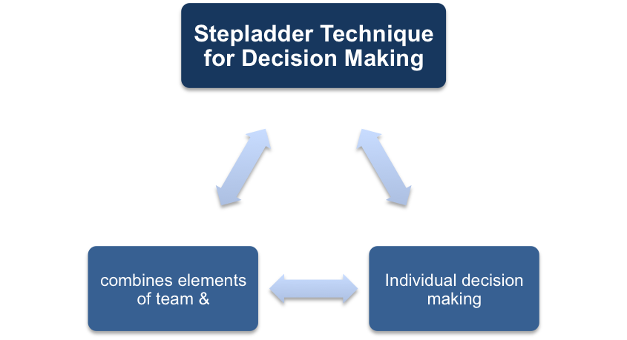](http://www.free-management-ebooks.com/news/wp-content/uploads/2016/12/s1.png)

The next time you have a decision to be made which requires input from a number of different team members, you will want to think carefully about using this model.

The idea behind the Stepladder Technique is the fact that there are inevitably going to be a variety of personalities within your team – and some of those personalities will be ‘louder’ than others. In other words, some team members are going to be aggressive in making sure their opinions are heard, while others will take a passive approach. In order to hear everyone’s opinion equally, you need to make sure that all have a chance to present their thoughts in a way that isn’t intimidating or overwhelming.

[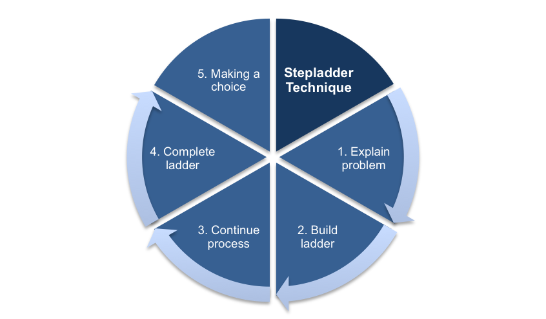](http://www.free-management-ebooks.com/news/wp-content/uploads/2016/12/s2.png)

In order to use the Stepladder Technique in your own decision making, follow the five simple steps below.

**Step One – Explain the Problem**

When first getting started, you will want to inform everyone in the group as to the problem that needs to be solved. This step will serve to inform individuals that they are being included on the team that is going to solve the problem, and they will have a chance to think about it on their own. Providing everyone with space is important at this step – if you don’t allow them to think individually before coming together, you are going to wind up with opinions that are influenced by the thoughts of others.

**Step Two – Build the Ladder**

After a period of time has passed, you are going to need to ask two members of the group to come together in order to discuss the problem. These individuals will have already had the chance to think about the problem on their own, so when they come together they will be prepared with some ideas that can be discussed. Provide them with a private, comfortable setting in which they can talk about all of the various issues at hand within this decision.

[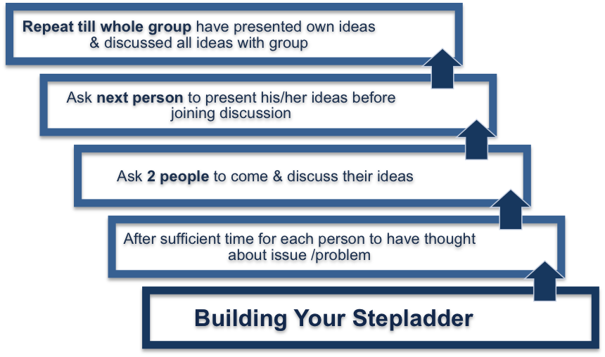](http://www.free-management-ebooks.com/news/wp-content/uploads/2016/12/s3.png)

**Step Three – Continue the Process**

Once the meeting has been held between the first two individuals, you are then going to ask a third person to join in on their discussions. The format of this meeting is crucial to the success of the process as a whole. When the third person joins in, they are going to first present their thoughts to the other two before anything is discussed as a group. This way, the third person won’t have their opinions colored by the opinions of the first two. You are trying to avoid ‘group think’ with this approach – you want everyone who comes in to the group to be able to offer their own thoughts, unaffected by the thoughts of others on the team.

**Step Four – Complete the Ladder**

As you might expect, the fourth step is to simply continue on until all of the team members have been added to the meetings. Each new person that comes in to the room should be given time to present their thoughts without hearing about anything else that has been discussed previously. Once the new person is given a chance to present, you can then fill them in on the other ideas so they are fully up to speed on what the group has been discussing.

**Step Five – Making a Choice**

The final step in the process is, of course, making a decision. The decision should only be made after all individuals have been added into the group, and all opinions have been heard. Even if you think that a decision is obvious after just the first few individuals have had a chance to talk, you should still see it out all the way through to the conclusion. With all of the ideas and opinions out in the air, you should be able to make a team decision that is in the best interest of the organization as a whole.

When all is said and done, the overall purpose of this method of decision making is to make sure you hear from everyone equally. If you were to simply call a meeting with all of the team members in order to make a decision, you would be unlikely to hear from everyone in a setting that made them feel comfortable. Some people are overwhelmed by large meetings, and they may be too nervous to truly outline their thoughts on the topic. Those thoughts are important, however, and using the Stepladder Technique will make it more likely that you are going to get everyone’s honest and open opinions on the topic.

[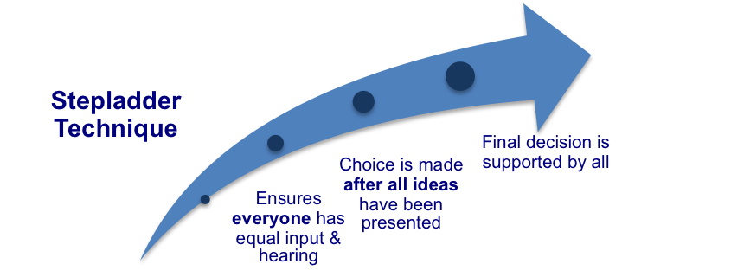](http://www.free-management-ebooks.com/news/wp-content/uploads/2016/12/s4.png)

The Stepladder Technique is not going to be appropriate or even necessary for every group decision that needs to be made, but it can be the perfect tool for some cases. If you have a large team that needs to make a decision – and that team is made up of a variety of personality types – going through the Stepladder process is a great idea. When done correctly, this model doesn’t have to be particularly time consuming and it can lead to a logical choice that is supported by a majority of your team.

**Key points:**

* The Stepladder technique combines elements of both team and individual decision making into a tool that is able to get the best from everyone involved.
* The first step is to inform individuals that they are being included on the team that is going to solve the problem, and they will have a chance to think about it on their own.
* Ask two members of the group to come together in order to discuss the problem.
* Some time later, ask a third team member to present their thoughts to the existing two and then join in the discussion.
* This step is repeated for the remaining team members.
* The purpose of this method of decision making is to make sure you hear from everyone equally.
* The Stepladder Technique will make it more likely that you are going to get everyone’s honest and open opinions on the topic.

**7 Steps to Analyze a Problem – The Devil’s Advocacy Technique**

Teams often struggle to make good decisions, dragging down their team’s performance.  In fact, one of the key predictors of team performance is the decision-making process employed by the team.  But, many of us don’t use any structured approach to solve problems and make decisions, and our teams suffer from that lack of structure.

 Further, I’ve written previously about how important conflict is to effectively analyze arguments and make great decisions as a team.  After all, the gains teams offer only come through the rubbing of ideas against other ideas.  Here’s an easy process – called the Devil’s Advocacy Technique – you can use to [program healthy conflict into a group discussion](http://www.ryanhartwig.com/6-strategies-to-stir-positive-conflict/).

 The Devil’s Advocacy Technique involves a group developing a solid argument for a recommended course of action, then subjecting that recommendation to an in-depth, formal critique. The critique calls into question the assumptions and recommendations presented to the devil’s advocate, and attempts to show why the recommendations should not be adopted. Through repeated criticism and revision, the approach leads to mutual acceptance of a recommendation.

[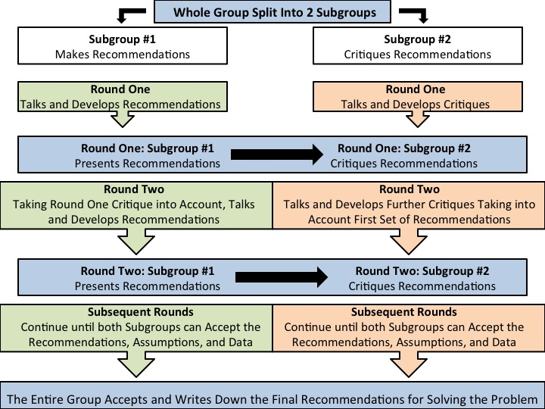](http://www.ryanhartwig.com/wp-content/uploads/2013/04/Slide1.jpg)

Because good recommendations based on solid assumptions will survive even the most forceful and effective criticism, this approach is likely to yield sound judgments or recommendations. Here are 7 steps to follow in using the devil’s advocate approach to solve thorny problems:

1. Identify a problem needing group analysis and decision making.
2. Divide the group or team into two equally-sized subgroups. Assign one subgroup to play devil’s advocate (DA subgroup) and the other to develop an affirmative recommendation (AR group).
3. After separating into subgroups, instruct the AR group to develop a set of recommendations and build an argument for them, supported by all key assumptions, facts, and data that underlie them. That group writes out the recommendations, assumptions, facts, and data on a white board or large piece of paper. Meanwhile, instruct the DA subgroup to prepare for their critique by discussing the case and identifying critical assumptions, data, and facts the other group might miss.
4. Then, join both subgroups together.  Instruct the AR subgroup to present its recommendations and assumptions to the devil’s advocate subgroup.  The DA subgroup critiques the recommendations, attempting to uncover all that is wrong with the recommendations, assumptions, facts, and data and explaining why the recommendations should not be adopted.
5. Then, separate the subgroups again so that the AR group revises its recommendations to answer the critiques, while the DA group works to find more critiques that would strengthen the recommendation.
6. Repeat Steps 4 and 5 until both subgroups can accept the recommendations, assumptions, and data.
7. Once both subgroups agree on a recommended solution, move forward and enact the recommendations.

 It’s amazing the enormous difference following a careful process can make for a team.

**Fishbowl Technique**



The fish bowl activity is used to manage group discussion. The general idea is that rather than a large group having an open discussion about something, which can be difficult to handle and often only benefits a few active participants, a smaller group (ideally 3 – 6 people) is isolated to discuss while the rest of the participants (maximum of 50 people) sit around the outside and observe without interrupting. Facilitation is focused on the core group discussion. Less people = easier to facilitate.

"Fishbowls are useful for ventilating “hot topics” or sharing ideas or information from a variety of perspectives. When the people in the middle are public officials or other decision-makers, this technique can help bring transparency to the decision-making process and increase trust and understanding about complex issues. Sometimes the discussion is a “closed conversation” among a specific group. More often, one or more chairs are open to “visitors” (i.e., members of the audience) who want to ask questions or make comments. Although largely self-organizing once the discussion gets underway, the fishbowl process usually has a facilitator or moderator. The fishbowl is almost always part of a larger process of dialogue and deliberation."

Example

‘Fish battle’: ‘Instead of the typical 3-6 seats in the middle for the talking participants, here it’s a one-on-one debating the pros and cons of a given subject. Participants outside the duelling duo tend to take one side and when they want to enter the battle they gently tap the shoulder of the duellist – civilised fishes we are! An alternative to this option is the Samoan circle. Lessons about the fish battle option include:

* This divergent option (read: brings lots of ideas, not structure) works best with a wider group and as a brainstorming option;
* It’s advisable to note down the key discussion points or you might end up with a rich but undocumented discussion;
* It puts the emphasis on having to listen carefully
* You may want to have a standing outer circle to avoid outer participants to fall into sleep.

*Advice for CHOOSING this option (tips and traps)*

1. As an alternative to traditional debates
2. As a substitute for panel discussions
3. To foster dynamic participation
4. To address controversial topics
5. To avoid lengthy presentations.
6. Analyze the appropriateness of this technique to the objectives of the event.

*Advice for USING this option (tips and traps)*

1. Obtain agreement from the event organizers to implement a fishbowl.
2. Communicate ahead of time with anyone you specifically want to participate in the fishbowl, explaining how the process works and what their role will be.
3. Make sure that the physical space permits a fishbowl setup
4. A few chairs in an inner circle (elevated if necessary to be visible to all)
5. Concentric rings of chairs and/or round tables around the inner circle;
6. Aisles to permit easy access to the inner circle
7. Microphones if needed
8. Easel stands or paper on walls for written or graphic recording of key ideas is sometimes helpful
9. To begin, invite the representatives to sit up front, explain to the group how the process will work, and open the floor with a provocative question, inviting the representatives in the fishbowl to comment.
10. Allow about 5-10 minutes for discussions in the core group, before opening up the floor for questions for another 10 minutes.
11. Give the core group a time limit after which the observers can then ask a question or comment on a particular part of the discussion.
12. Invite observers to join the discussion or switch places with one of the core group so that the discussers are rotating.
13. After a certain amount of time (e.g. 5 mins), swap the groups so that observers now discuss while the discussers now observe. After the second group has discussed, get them to reflect on each other’s discussions.